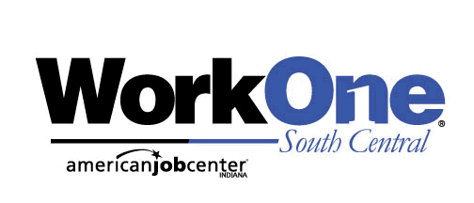
Board Report
January 15, 2020
Participant Services Goals for PY’19
Program | Regional Plan Goals | Carry-In Clients | New PY’19 Enrollments (July 1 – Dec 31) | Total | % of Goal
WIOA Adult | 820 | 181 | 149 | 330 | 40%
WIOA DW | 165 | 48 | 46 | 94 | 57%
WIOA Out of School Youth | 143 | 34 | 23 | 57 | 40%
WIOA In School Youth | 36 | 16 | 2 | 18 | 50%
JAG | 320 | 266 | 166 | 432 | 154%
.
Performance Highlights
- Customer Service Data has been received from DWD for Third Quarter 2019 (July – Sept) Overall Customer Satisfaction for Region 8 was at 93.88%. The Region 8 Employer Satisfaction rate for Third Quarter 2019 was at 100%.
- WorkKeys- Over 80 assessments were administered in the last three months. The following National Career Readiness Certificates were awarded to Region 8 customers: 4 Platinum, 2 Gold, 8 Silver and 3 Bronze. Business Services staff continue to engage with employers at job fairs throughout the region to discuss the utilization of the assessments as part of their hiring process.
- Work Based Learning - in the last three months, an average of 16 customers were active in work-based learning (WBL) opportunities with regional employers. The WIOA Performance Support Grant awarded to the region has allowed us to provide work based learning opportunities to 53 customers.

TAA and Rapid Response Activities
- No Rapid Response or TAA Orientations during October-December.
- TAA Engagement- Region 8 currently has 31 TAA enrollments. Four (4) new enrollments occurred between October and December 2019. 14 customers were participating in RTAA, four (4) are attending training and three (3) entered into full time employment.

Business Services

- From July to December 2019, a total of 234 Distinct Employer contacts were made which represents an achievement of 39% of our annual program goal of 600 contacts.
- From July to December 2019, a total of 738 Business Contacts were made which represents an achievement of 44% of our annual program goal of 1,680 contacts. Some of the employers visited this quarter included the following: West Baden Hotel, French Lick Springs Hotel & Resort HR, CornPro, CVS, Pittman Concrete, Warrant Technologies, geoConvergence, McDonalds-Bedford & Mitchell and MSP Aviation.
- Ongoing Hiring Events and Job Fairs continued throughout the Region. From July to December 2019, 80 Mini Job Fairs were hosted, and over 13,000 informational e-newsletters were sent promoting job fairs, workshops, training opportunities and Veterans services.

PY 18-19 WIOA Performance Support Grant (PSG) Outcomes
Initiative #1- Work-Based Learning for Adults and Youth- 43 Participants have been provided with a work experience activity. 32 have successfully completed their work experience, six (6) dropped out and five (5) are still participating. Of the 32 who have been exited from the activity, 25 are currently employed and seven (7) are unemployed.

Initiative #2- Work-Based Learning for Ready2Work Participants- 10 Participants were provided with a work experience activity. Five (5) are employed. Of the five (5) unemployed, one (1) is still actively working with a WorkOne career advisor for job placement, three (3) have asked to be exited due to no longer seeking employment and one (1) has been exited due to medical reasons. Four of these individuals have also earned their National Career Readiness Certificate (NCRC).

Initiative #3- Supportive Services for HIRE/WIOA Customers- Region 8 has served 30 participants. 23 of those individuals are currently employed earning $10.00-$18.75 an hour.

Initiative #4- Digital Literacy Workshops for WorkOne Customers- Region 8 had participants complete over 400 Digital Literacy Workshops from October 2018 to December 2019. Four (4) individuals have been studying for their MOS certification. Two (2) have taken the required test and both have passed. Two are scheduled to take the test in the next 45 to 60 days.

Customer Spotlight: Hunter Young—Performance Grant Success

Hunter Young has just earned his second official certification in entry-level professional office computer skills from Microsoft Corporation for both Microsoft Word 2016 and Microsoft Excel 2016. This makes Hunter among the relatively few individuals who hold a double Microsoft Office Specialist (MOS) certification.

Hunter graduated from Edgewood High School in May 2018. While attending High School, he participated in the Information Technology Program at the Hoosier Hills Career Center. Hunter's previous work experience was in a seasonal retail position at Michael's Arts and Crafts.

Hunter began his association with WorkOne as he was seeking a better job. He participated in a 4-week Work Experience (WEX) at the Bloomington WorkOne Office where he gained administrative skills and then transitioned to an 8 week WEX at Monroe County Community School Corporation in the Technology Department. He also completed WorkKeys Testing during that time and earned a Platinum Level Certificate.

Hunter has already started on his career path, and he is now employed part-time at Ivy Tech Bloomington assisting students with express enrollments.

While Hunter is still considering furthering his formal education, he is now studying to take his MOS test in Access. “The Big 3 certifications to have are Word, Excel, and Access” he says. “WorkOne is helping me move toward earning that. I really want to thank Gail Mitchell and Richard Hamlin and the other professionals at WorkOne for working with me and for pointing me in this direction to move ahead, and for easing my own path forward, and for making all of this possible”.

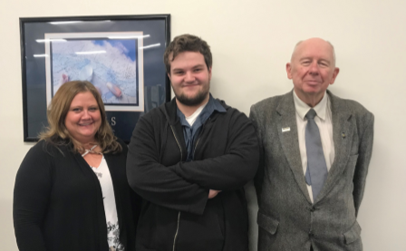

Left to right: Monroe County Career Advisor Gail Mitchell, Hunter Young and Microsoft Instructor Dr. Richard Hamlin

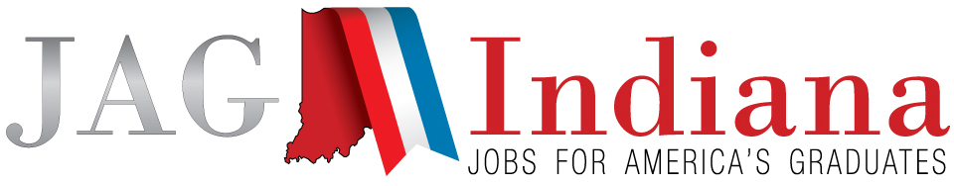

JAG National Student Leadership Academy: Washington D.C.

Eight (8) students from the Region 8 Jobs for America's Graduates (JAG) program recently attended the JAG National Student Leadership Academy (NSLA) in Washington, DC. After an application process, each student was selected based on their enthusiasm and willingness to go above and beyond to better themselves. Their time spent at NSLA was filled with interactive learning as well as networking with fellow JAG student leaders from all over the United States. They were given the opportunity to tour the US Capitol building, several monuments, and the Smithsonian museums. Three (3) of the students in attendance competed in the competitive events portion of the academy. Matt Waggoner from Washington High School and David Barton from Eastern Greene High School competed in the Employability Skills event where students were asked to prepare a cover letter and resume, fill out a job application, and complete a mock interview. Owen Taylor from Brown County High School competed in the Math Skills event where he completed a financial literacy exam. While none of them placed in their respective competitions, they all agreed the lessons they learned by going through the process were worth the effort.

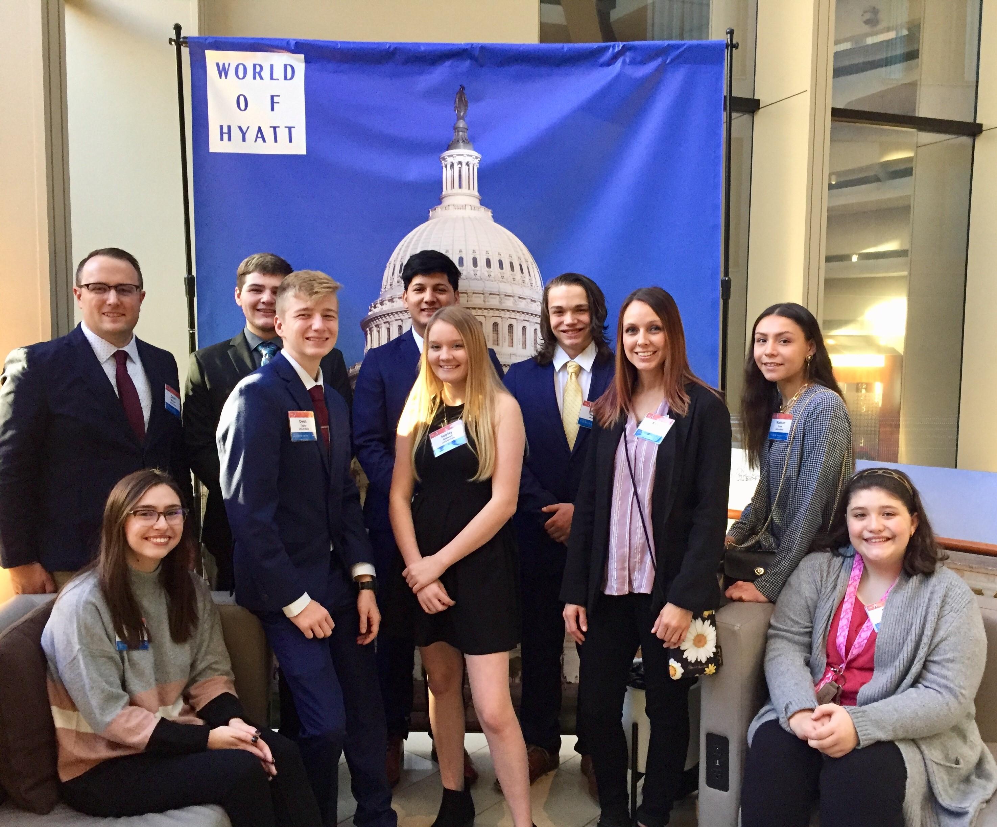

In Attendance: Hannah Elliott (Owen Valley), Owen Taylor (Brown County), Hayley Stewart (Mitchell), Madison Drew (Edgewood), Megan Poe (Paoli), David Barton (Eastern Greene), Oscar Dubon (Washington), Matt Waggoner (Washington), and JAG staff chaperones Katie Cook and Derek Morgan.

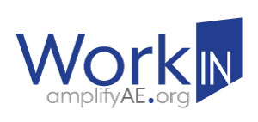
WorkINdiana programs continue to have great participation and success. Region 8 enrolled 95 customers during the period July 1, 2018 – December 31, 2019. 83 of the 95 enrolled customers completed training, resulting in an 87.4% completion rate which exceeds the state expectation of 80%. Of those completers, 70 students (84.3%) earned a certification which also exceeded the state’s goal. Finally, 54 individuals who earned a certification are employed for a 77.1% employment rate which exceeds the state expectation as well. These job placement numbers are likely to increase since 5 customers who earned a certification in December are currently actively looking for jobs.
DWD recently announced a grant opportunity for Regional Workforce Boards to apply for more WorkIN funding to continue operating the program through June 30, 2020. Region 8 intends to partner with local Adult Education providers to apply for these additional funds. Until more funds are received, the region will continue to utilize the WIOA Performance Support Grant and CDL/CNA Workforce Ready Grant funding to ensure customers have opportunities to attend short term training programs and earn certifications necessary to help reduce the region’s labor shortage.

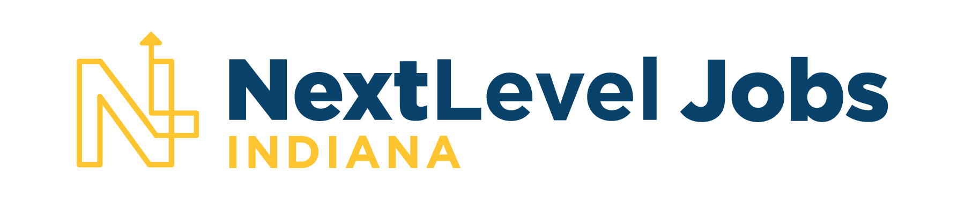

In the last legislative session, DWD received approximately $20 million for the next two years to obligate to employers for the Next Level Jobs (NLJ) Employer Training Grant. In July 2019, local Business Services Staff began working with regional employers to develop training plans for the NLJ Employer Training Grant through the reimbursement phase. Currently, Business Services Staff are assisting 28 area businesses with applying for these grant funds.

The response to the NextLevel Jobs Workforce Ready Grant (WRG) initiative was greater than was anticipated. DWD recently reviewed available funding levels and have announced changes designed to help sustain Workforce Ready Grant funding throughout the program year. One change made was to more strictly enforce the statewide five flames demand occupation expectation for all non-credit bearing training programs. Any WRG-authorized program that does not train students for a statewide five flame demand occupation was removed from the approved training provider list and no further students can be enrolled in these trainings using WRG funds effective January 1, 2020. Customers are being encouraged to contact their local WorkOne office to potentially receive additional training assistance as well as supportive services. Information about the Employer Training Grant and the Workforce Ready Grant can be found at the following website: https://www.nextleveljobs.org/.

